🌧️ Natural Disaster Project — Flooding / Heavy Rain
1. Main Goal
Create a web application that allows people to anonymously report heavy rainfall and flooding in their area and allows the system to visualize areas where flooding is becoming dangerous.
The system should help:
- Residents report flooding quickly.
- Other people see potentially dangerous areas.
- Authorities/administrators monitor developing situations.
- Drivers receive warnings about dangerous roads – radio warnings from the reporters.
- People potentially evacuate or request help before the situation becomes critical.

2. Basic Concept
A person notices flooding and opens the website:
📍 Select/report their approximate location
↓
🌧️ Select flooding severity (Low, Medium, High)
↓
📝 Optionally provide additional information
↓
📤 Submit report
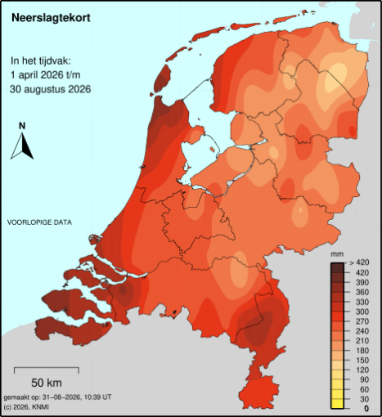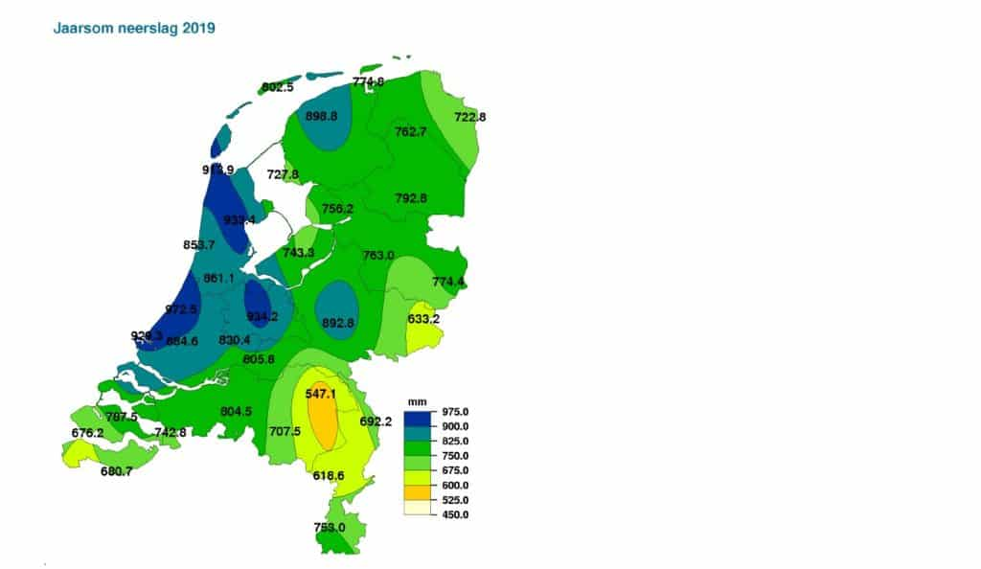

Individual addresses are not displayed publicly.
Instead, reports are aggregated into an approximate flooding zone.

3. Flood Severity Levels
You could start with three simple levels.
🟦 LOW — Watch
Minor flooding or heavy rainfall.
Possible parameters:
- Puddles covering parts of roads.
- Drains struggling to handle rainfall.
- Water approximately 0–10 cm deep.
- Roads generally still passable.

🟦 MEDIUM — Caution
Flooding is becoming problematic.
Possible parameters:
- Water covering significant parts of roads/paths.
- Difficult driving conditions.
- Water approximately 10–30 cm deep.
- Some roads may become unsafe.
- Basements or low areas potentially affected.

🟦 HIGH / CRITICAL — Danger
Flooding presents a serious threat.
Possible parameters:
- Water approximately 30+ cm deep.
- Vehicles potentially unable to safely pass.
- Rapidly increasing water levels.
- Buildings or important infrastructure potentially affected.
- Roads becoming impassable.
- Authorities' predefined danger threshold exceeded.
System behavior:
🚨 Warn drivers approaching the area.
🚨 Notify responsible authorities/administrators.
🚨 Potentially trigger an evacuation warning depending on official rules.

4. Important: Don't Base Danger Only on Water Depth
This would be an important point for your project.
30 cm of slowly rising water isn't necessarily equivalent to 30 cm of fast-moving water.
Therefore, your report could eventually contain:
Flood level:
○ Low
○ Medium
○ High

Water movement:
○ Still
○ Moving slowly
○ Moving quickly

Road condition:
○ Passable
○ Difficult
○ Impassable
However, for a simple first version, you could keep only the flooding level.
Later versions could introduce the additional parameters.

5. Location Privacy
This is one of the most important parts of your idea.
The system should not publicly reveal the exact address of the person submitting a report.
Instead:
User submits
123 Example Street
Database stores
latitude: 52.xxxxx
longitude: 6.xxxxx
but the public map displays an aggregated area rather than the exact location.

6. Report Aggregation
You need a rule determining when multiple reports become a single flooding area.
For example:
Reports within 500 meters of each other are considered part of the same flooding zone.
Then:
Report A ── 200m ── Report B
│
350m
│
Report C
These become one zone.
But:
Report A ─────────────── 2km ─────────────── Report B
would create two separate zones.
The radius should ultimately be configurable by an administrator.

7. Combining Multiple Reports
The system shouldn't necessarily treat every report equally.
For example:
Area A

LOW
LOW
MEDIUM
LOW
could produce:
🟦 LOW–MEDIUM flooding
Whereas:
Area B

HIGH
HIGH
MEDIUM
HIGH
could become:
🚨 CRITICAL flooding
3 high-severity reports detected.
You could create a simple scoring system.
Example:
Report | Points
Low | 1
Medium | 2
High | 3

8. Time Is Important
Flood reports should expire.
A report from yesterday shouldn't necessarily continue affecting today's map.
Or:
LOW → 60 minutes
MEDIUM → 90 minutes
HIGH → 120 minutes

14. Preventing Fake Reports
Since anyone can submit a report, you need some protection.
For a student project, simple mechanisms are enough:
Rate limiting
For example:
Maximum 3 reports per user per 10 minutes.
Report confirmation
Other users can confirm:
👍 "I can confirm this flooding."
Reputation
A user's reports could become more trusted if other people consistently confirm them.
Administrator verification
Authorities/admins can mark:
UNVERIFIED
or
VERIFIED

16. Notifications
Users could receive:
Website notification
🚨 Flood warning in your area.
Browser notification
⚠ Heavy flooding reported nearby.
Email
A flooding warning has been issued for an area you're monitoring.
For the student MVP, browser notifications or in-app notifications would probably be enough.

